Computer Lab Project (C++)

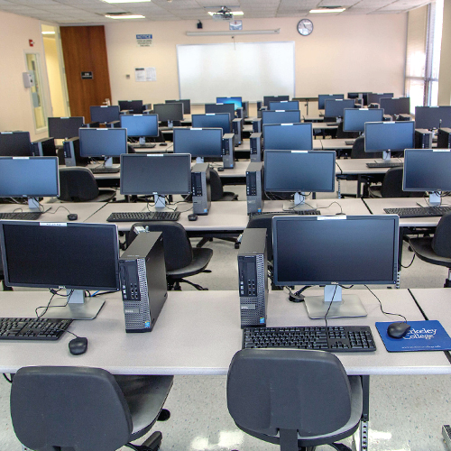

1.1 User introduction

* Student: access to use the computer lab room
* Teacher: permission for the student booking application
* Administrator: Create account for Student and Teacher

1.2 Computer Lab introduction

Total 3 Computer Lab

* No.1 Lab---- Maximum people number: 20
* No.2 Lab---- Maximum people number: 50
* No.3 Lab--- Maximum people number:100

1.3 Application introduction

* Every week the student application will be clear by admin
* Student can book for the lab. From Monday to Friday, each day can be separate morning or afternoon.
* Teacher can give permission for the student application: Pass or Fail

1.4 System requirement detail

* Login Page, identity that can choose by user and operation

1. Student
2. Teacher
3. Admin
4. Log out

* Information needs for the login to main menu page

1. Student: student ID, name, password
2. Teacher: teacher ID, name, password
3. Admin: Admin name, password

* Student (what can student do)

1. Application --- booking
2. Check --- check for the booking
3. Check All booking --- check all booking status and details
4. Cancel booking
5. Log Out

* Teacher (what can teacher do)

1. Check all appointment --- All details and status
2. Log out
3. Appending the booking

* Admin

1. Add new account --- Add student and teacher (must check if there any duplicate)
2. Check account --- check the information of student and teacher account
3. Check lab --- check the status of all 3 computer labs

Mind MAP

